Determination of Concentration of Quinine in Tonic Water using Spectrofluorometry

Max Shi

*Department of Chemistry, Stevens Institute of Technology, Castle Point on Hudson, Hoboken, NJ 07030.*

*Performed October 26, 2020; submitted November 4, 2020.*

**Abstract**: Spectrofluorometry was used to determine the unknown concentration of quinine in tonic water. Because quinine fluoresces, a spectrofluorometer was used in combination with Standard Ordinary Linear Calibration to determine this unknown concentration. Five 100.0 mL calibration solutions of quinine, of 0.10, 0.20, 0.60, 0.80, and 1.00 ppm, were prepared from a 40.0 ppm stock solution of quinine hemisulfate salt monohydrate as the solute and dilute sulfuric acid as the solvent, and each solution’s fluorescence was measured with the excitation wavelength set to 247 nm. After creating a calibration curve from the data, 1 mL of tonic water was diluted into 250.0 mL solution and was loaded into the spectrofluorometer, where an absorbance value was taken. This process of diluting the tonic water and taking a measurement was repeated three times. From the average of the measured absorbances, the concentration of quinine in tonic water was determined to be 56.49 ppm.

**Introduction**

Spectrofluorometry is a method in analytical chemistry to determine the concentration of an unknown substance that fluoresces when excited by UV light. Because the intensity of the fluorescence is proportional to the concentration of the substance in solution, Standard Ordinary Linear Calibration can be used to recover the unknown concentration of a fluorescent compound in solution. To carry out spectrofluorometry, a special quartz cuvette is used that is clear on all sides. This cuvette is filled with a substance, either a known calibration solution or the unknown solution, and placed into the spectrofluorometer. Then, the reading is taken with the machine by setting the excitation wavelength for the UV light hitting the cuvette and the range of wavelengths for the detector to measure coming out of the cuvette. Finally, the intensity at the wavelength of maximum intensity is used to construct the calibration curve. The general setup for this technique is detailed in Figure 1, where the two monochromators are used to select the wavelength for the excitation UV light and the measured light emission.

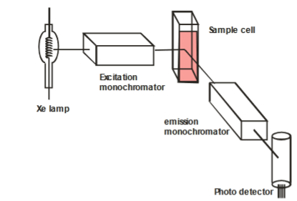

Figure 1: Internal Setup of Spectrofluorometer

**Experimental**

Tonic water, the quinine hemisulfate salt monohydrate (CAS#: 207671-44-1) and dilute sulfuric acid (CAS#: 7664-93-9) were given by the TAs. The spectrofluorometer used in this experiment was a Perkin Elmer LS-45 Spectrofluorometer.

To begin, the 250.0 mL stock solution of 40.0 ppm quinine hemisulfate salt monohydrate was created with 10 mg of the salt placed into a 250-mL volumetric flask and diluted to the line with dilute sulfuric acid. Then, five 100.0 mL calibration solutions were created by adding 0.25, 0.50, 1.50, 2.00, and 2.50 mL of the stock solution, each to their own 100-mL volumetric flask, and diluted to the line with dilute sulfuric acid. This created five calibration solutions of 0.10, 0.20, 0.60, 0.80, and 1.00 ppm.

Next, three diluted solutions of tonic water was produced by adding 1.00 mL of tonic water to each of three 250-mL volumetric flasks and diluting to the line with sulfuric acid.

Then, for each of the calibration solutions, from least concentrated to most concentrated, the spectrofluorometry cuvette was filled with the solution and a measurement was taken with the spectrofluorometer with the excitation wavelength set to 247 nm and the measured range from 300 nm to 600 nm. The same process was repeated for each of the three dilute tonic water solutions. Figure 2 illustrates the readings on the spectrofluorometer.

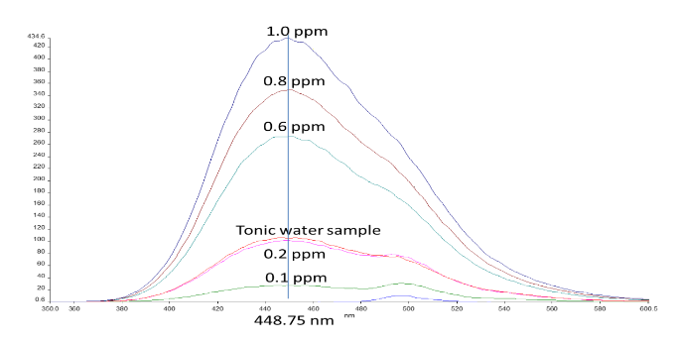

Figure 2: Spectrofluorometry Spectrum for Quinine Calibration Solutions and Tonic Water Solutions

From the readings, 448.75 nm was selected as the maximum intensity wavelength. Using the emission readings from these points, the following calibration curve was created, illustrated in Figure 3.

Figure 3: Calibration Curve for Emission of Quinine Hemisulfate

The average emission reading for the three unknown readings was 160.86. Plugging this in for y in the regression equation, the calculated ppm of quinine hemisulfate was 0.273 ppm. After converting this to quinine with the molar mass ratio of 324.44 g/mol to 391.47 g/mol and working backwards from the dilution by multiplying the concentration by 250 mL/1 L and dividing by 1 mL/1000 L, the calculated concentration of quinine was 56.49 ppm.

This technique of spectrofluorometry is very strong for determining the concentration of fluorescent compounds in solution. Because of the relative rarity of fluorescent compounds, spectrofluorometry can target specifically the molecule in question, which in this case, was quinine. However, due to the relative rarity, this technique is not applicable to a lot of compounds, as they do not fluoresce.

**References**

1. Attygalle, A. Instrumental Analysis I Lecture and Laboratory Manual <https://sit.instructure.com/courses/38802/files/6982711?module_item_id=1042514> (accessed Oct 11, 2020).
2. Harris, D. C. *Quantitative Chemical Analysis*, 8th ed.; W.H. Freeman and Co: New York, 2010. Chapter 17.